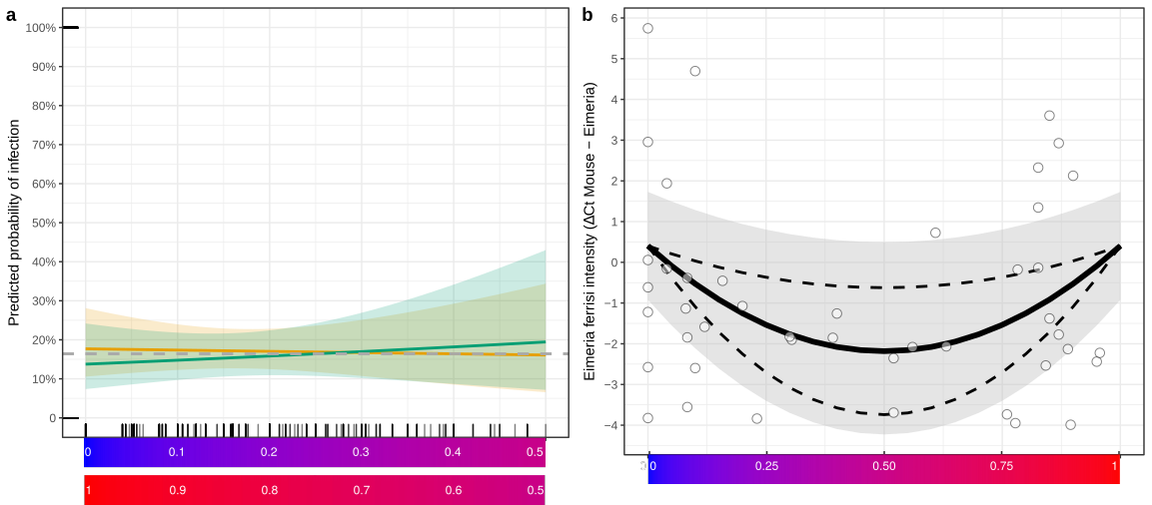
Supplementary Figure S6. Probability of infection is constant and intensity of Eimeria ferrisi infection is reduced in hybrids. The predicted probability of infection does not differ in more admixed mice (a) for males (green) and females (orange)(average overall observed probability of infection (prevalence) for males and females considered together: grey dotted line). Eimeria ferrisi intensity (white dots = individual mice) is reduced at intermediate values of the hybrid index (b), represented as a gradient ranging from 0 (pure Mmd, in blue) to 1 (pure Mmm, in red). The optimized fit is represented by a solid line, the 95%CI of the fit as all parameters are allowed to vary in their 95%CI, is plotted as a grey ribbon. The 95%CI of the hybridization parameter alpha, as all parameters are fixed to their fitted value while alpha is allowed to vary in its 95%CI, is plotted as dashed lines.

